Test Cases

R1: Order Validation

Categories | Requirement | Test cases | ID
CVV Length  CVV Value | 3  numeric | Valid: 3 numbers  (CVV = 123)  Invalid:  length 2, numeric (CVV = 12)  length 3, all letters  (CVV = abc)  Boundary (Invalid):  length 3, 2 numbers followed by a letter  (CVV = 12a) | FR-OV-03
Expiry Date | Not before 01/26,  MM/YY format | Valid:  Expiry date = 01/27  Boundary (Valid):  Expiry date = 01/26  Invalid:  Expiry date = 01/25 (expired)  Expiry date = 01 (wrong format) | FR-OV-01
Card Number | Length 16 | Valid:  CN = 1234567890123456  Invalid:  CN = 12345678901234567 (16 digits)  CN = 123456789012345a  (Letters included) | FR-OV-02
Order cost | Added pizza price plus delivery fee | Valid:  Correct total plus delivery fee  Invalid:  Incorrect total | FR-OV-08
Order date | Date before 01-01-2026,  Restaurant must be open | Valid order date  Invalid:  Order date invalid  Restaurant closed | FR-OV-09
Pizza count | Between 1 and 4 | Boundary (Valid):  C = 1  C = 4  Boundary (Invalid):  C = 0  C = 5 | FR-OV-04  FR-OV-05
Source of pizza | All pizzas come from the same restaurant | Valid:  All pizzas from one restaurant  Invalid:  Pizza not defined in any restaurants  Pizzas from multiple restaurants | FR-OV-06  FR-OV-07

Results and Evaluation

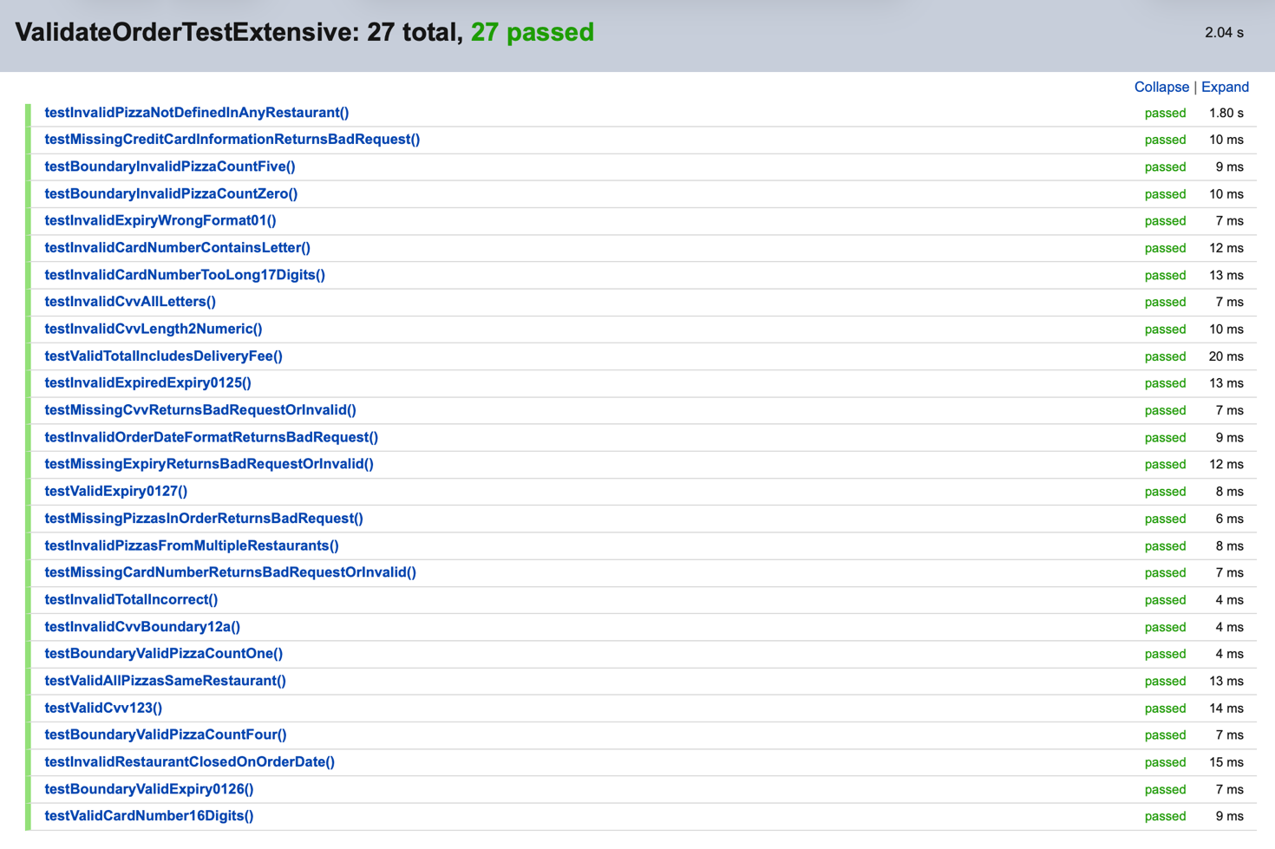
The tests uncovered several errors in the logic and implementation of the code. The delivery charge wasn’t being added correctly to the total of the pizzas resulting in several false classifications of valid orders and misclassifications of the true cause of an invalid order. This error was easy to fix once found. Testing the border case for when the expiry date is in the same month of the order revealed that the system considered that invalid when it should actually be valid as the card won’t expire till the end of the month. Once identified, the issue was resolved by validating expiry dates at month granularity rather than using a raw date comparison.
Overall, the results indicate high effectiveness of functional and boundary testing for this requirement. Each validation rule was exercised independently, mirroring the ILP auto-marker’s behaviour and ensuring strong fault localisation. After fixes were applied, all validation codes were triggered exactly once by their corresponding test cases, providing confidence that the implementation aligns with the specification.
Residual risk remains low for order validation, as the logic is deterministic and fully exercised across all specified equivalence classes. Any remaining defects are likely to relate to malformed input beyond the specification rather than missing validation rules.

R2: Flight Path Generation
For the following requirements, they will all be tested together in one test which will generate the flight path of 10 unique valid orders.
FR-N-04: The system will avoid entering no-fly zones
FR-N-05: Once the drone enters the Central Area, it will not leave it again

FR-N-07: For valid orders, the system will return a sequence of positions representing the delivery path
This requirement was tested separately as well as in the tests above indirectly. In the test class CalcDeliveryPathTest, I test that given a valid order the system returns a path for each of the 7 restaurants given in the ILP coursework.

Results and Evaluation
FR-N-04 and FR-N-05
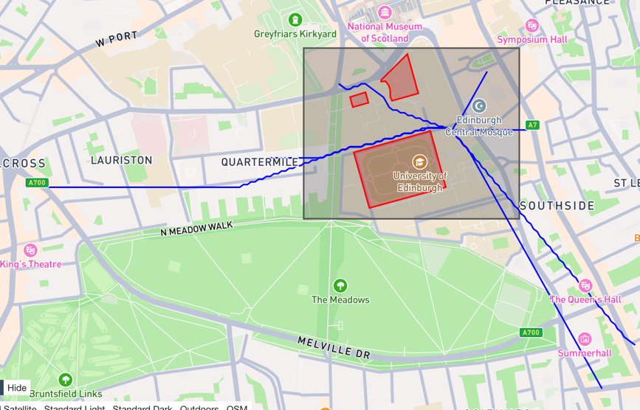
Through the inspection of this image generated by the geojson.io website, it can be seen that none of the paths enter the no-fly zones specified by the ILP specification nor does it leave the Central Area once it has entered it. FR-N-07 is satisfied as the sequence of positions returned were then put into geojson.io to create this image.
Tests were executed using the Spring test context to ensure realistic request handling and response generation.
FR-N-07
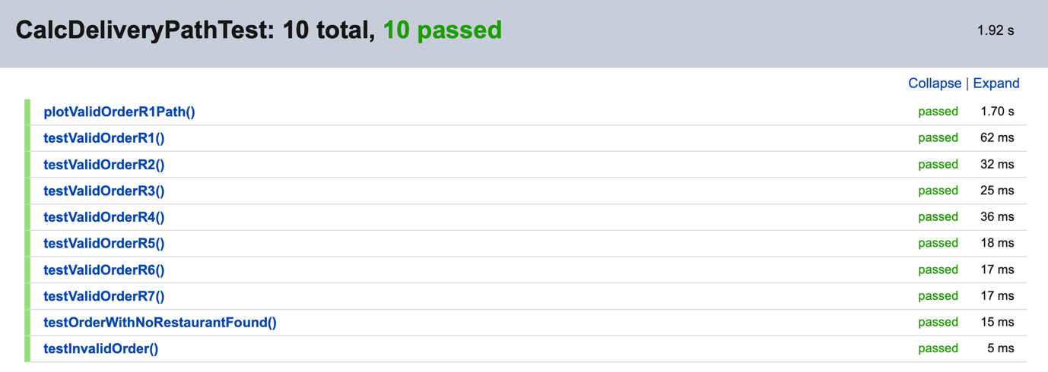
During testing I realised that my method for detecting no-fly zones didn’t account for if the path between two points outside of the no-fly zones cuts across one which resulted in the drone cutting through the corners of the zones. To fix this issue I increased the proximity threshold so that the path would be further from the zones.

Valid orders consistently produced delivery paths, indicating correct system-level behaviour. Confidence is high, with residual risk primarily related to floating-point precision and geometric edge cases.

R3: Drone Movement

Requirement | Test Level
FR-N-01 | Controller unit test
FR-N-02 | Controller unit test
UT-GEO-01 | Controller unit test
UT-GEO-02 | Controller unit test
UT-GEO-03 | Controller unit test
FR-N-03 | Integration / system

Most of the tests for drone movement are implemented as methods within my controller class as they are low level and deterministic. For this reason, they can’t be tested explicitly as unit tests very effectively. I did however test for consistency in the DroneMovementTest test class.

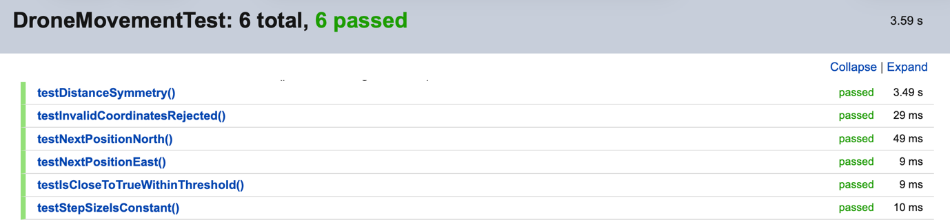

Results and Evaluation
As the requirements for drone movement are not difficult to implement and are straightforward to understand, further testing did not raise any errors or gaps in the code. These tests serve to check and assure us that the fundamental mathematical considerations of the system are correctly implemented.

Hover behaviour was validated indirectly through integration tests and manual inspection of generated paths. Overall confidence is high, with minimal residual risk, as errors in this area would likely surface immediately during higher-level testing.

